**BIT706 Programming 3 Assessment 3 3525331 Christopher Tipper**

**Part A Analyse new requirements:**

In order to transfer money from one account to another

As a customer

I need to have an account which allows to transfer funds into another account

Feature: Limiting amount from main account to transfer to another account

In order to meet the banks transfer account rules

As a Bank Manager

I need to keep to the limit of $2000.00 as much as possible

Scenario: Customer can transfer money under the limit

Given I have transferred $1000.00 to my other account

When I transferred money from main account to another account

Then I will have $1000.00 left to transfer

And am able to transfer up to $1000 more with a message “You have $1000.00 left to transfer”

Scenario: Customer can transfer money on the limit

Given I have transferred $2000 to my other account

When I transferred money from main account to another account

Then I will not be able to transfer anymore

And am at my limit to transfer money with the message showing “You have reach the limit of $2000.00”

Scenario: Customer can transfer money just over the limit

Given I have transferred $2050.00 to my other account

When I transferred money from main account to another account

Then I will not be able to transfer anymore and will incur a fee for going over the $2000.00 limit

And the message will show “Due to going over the $2000.00, a $80 fee will occur”

Scenario: Customer cannot transfer money over the limit by a certain number

Given I tried to transferred $2100.00 to my other account

When I transferred money from main account to another account

Then the transfer will be declined due to going over an excessive amount

And the user will have a message of “declined transfer, excessive amount too transfer”

But I can contact the bank for an one-off amount over $2099.99

**Part B Designing extensions to your existing classes:**

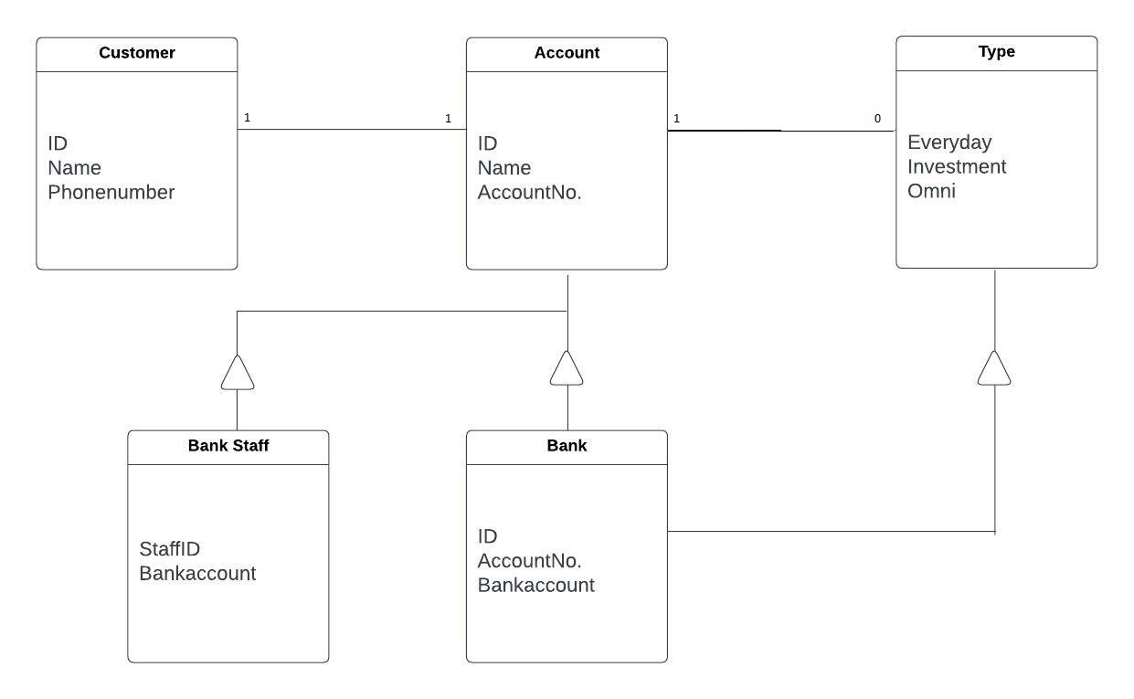

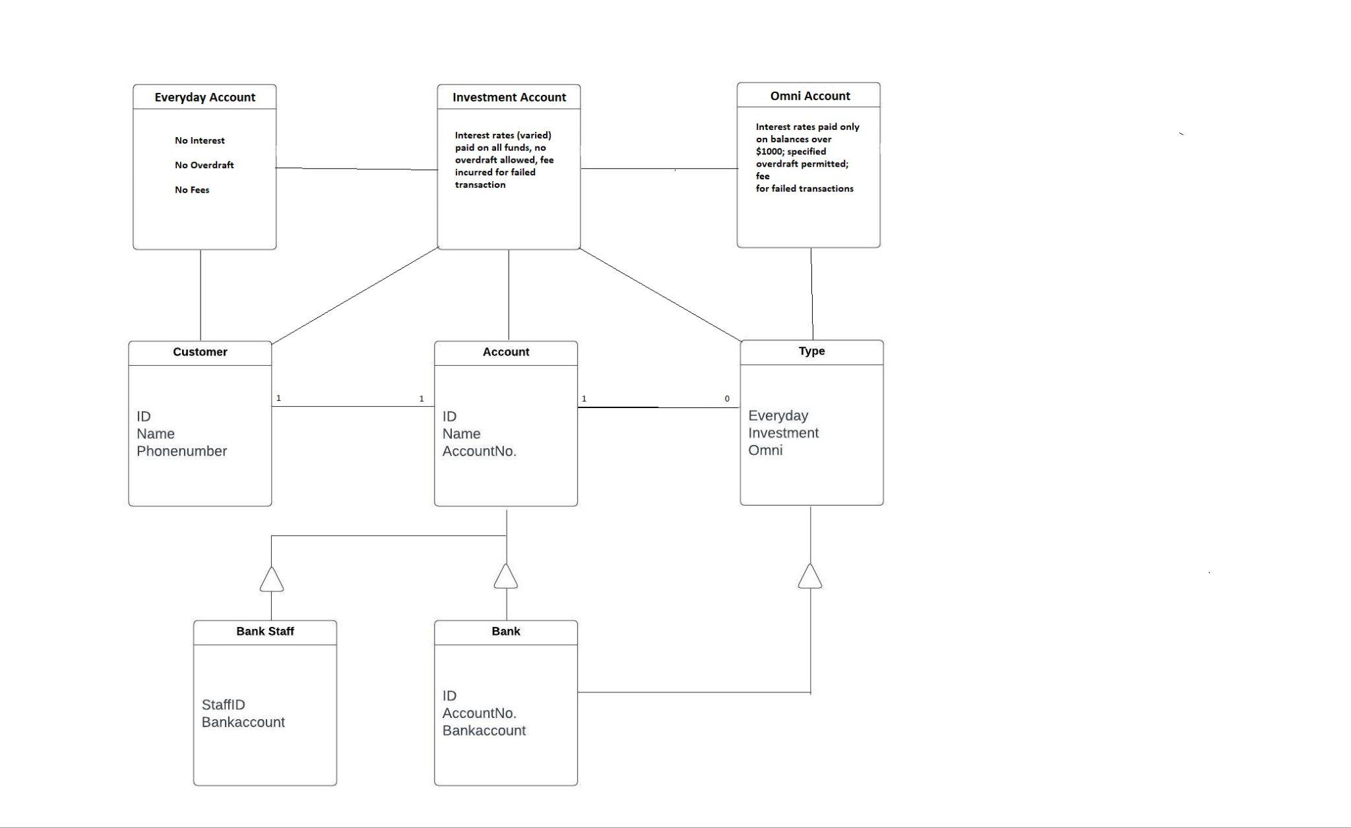

**Part G Provide a short user guide for your prototype:**

Welcome to the Banks prototype user guide. For the application, we have the following guide:

Step One: The main menu page will appear with the two options. Customers which will give you the options to add, edit, and delete a customer. The accounts menu takes you to an account of choice: Investment, Everyday, or Omni.

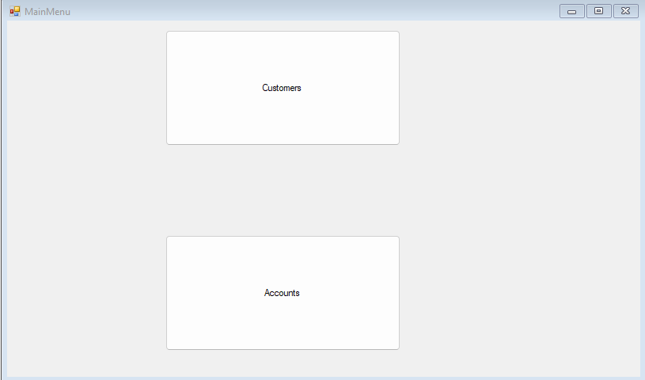

Step two, the menu either customer or accounts depending on which you have clicked will show up.

The Customer Menu will have the functions to change any customer details if needed.

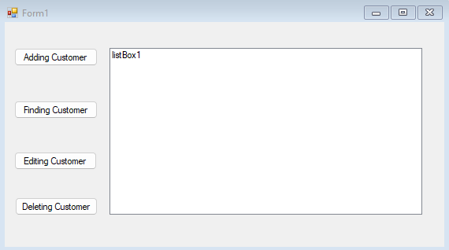

The manage accounts page is on the amount in an account, depositing in a account, withdrawing accounts, and transfer from one account to another.

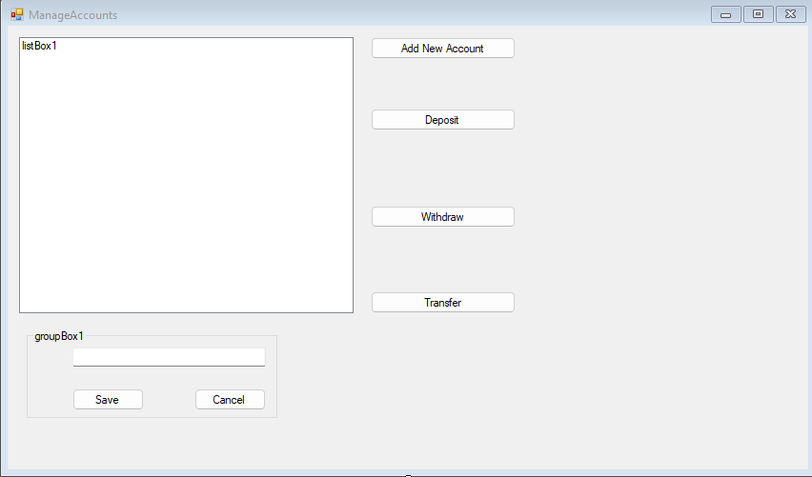

**Part H Module testing:**